PROJECT REPORT

DESIGN PROPOSAL DRAFT-II

**BASIC MODELLING OF LOW COST HUMIDIFICATION SYSTEM**

**FOR LCV**

REPORT BY

TANIMA SHARMA

AKSHAY SRIVASTAVA

# **NOMENCLATURE**

|  |  |
| --- | --- |
| **Cp,G (J/g K)** | Gas specific heat at constant pressure |
| $${\text{C}}_{\text{P,1}}^{\text{U}}\text{ (J/g K)}$$ | Specific Heat of Humidity (inlet) |
| $${\text{C}}_{\text{P,2}}^{\text{U}}\text{ (J/g K)}$$ | Specific Heat of Humidity (outlet) |
| **Cp,W (J/g K)** | Liq. Vapor Specific Heat (at ΔP=0) |
| **G (g/min)**  **g (L/min)**  **h (J/min K m2)** | Gas Mass flow rate  Gas Volumetric Flowrate  Convective Heat Transfer Coefficient |
| **kY (gdry gas/min m2)** | Mass Transfer Coefficient |
| **S (m2)** | Gas-Liquid Interface Surface |
| **To (K)** | Reference Temperature (298K) |
| **T1 (K) ,t1 (oC)** | Inlet Gas Temperature |
| **T2 (K) ,t2 (oC)** | Outlet Gas Temperature |
| **Ts (K), ts (oC)** | Liq. Temp. at Gas-Liq. Interface |
| **U1 (gliquid/gdry gas)** | Inlet Gas Absolute Humidity |
| **U2 (gliquid/gdry gas)**  **RH1 (%)**  **RH2 (%)**  **U2 (gliquid/gdry gas)**  **UG (gliquid/gdry gas)**  **Ww (g/min)**  **λ (J/g)**  **Re**  **Nu**  **Pr**  **μ (Pa.S)**  **ρ (g/cm3)**  **r (m)**  **d (m)**  **HT (J/ oC)**  **HDA (J/ oC)**  **HV (J/ oC)**  **hda (J/kg oC)**  **hv (J/kg oC)**  **mda (g)**  **mv (g)** | Outlet Gas Absolute Humidity  Relative Humidity at inlet  Relative Humidity at outlet  Volume Control w/ Assist Control  Pressure Control w/ Assist Control  Pressure Support Ventilation  Liquid Evaporation latent heat at To  Synchronised intermittent Mandatory Ventilation w/ volume control  Synchronised intermittent Mandatory Dynamic Viscosity of gas mixture  Density of Gas mixture  Radius  Diameter  Total Enthalpy  Enthalpy of dry air  Enthalpy of vapor  Specific Enthalpy of dry air  Specific Enthalpy of Vapor  Mass of Dry Air  Mass of Water |

**REPORT OUTLINE**

**NOMENCLATURE** 2

**EXECUTIVE SUMMARY** 3

**INTRODUCTION** 4

**HUMIDITY AND TEMPERATURE REQUIREMENT** 5

**BASIC DESIGN OF HUMIDIFICATION UNIT** 7

**MODELLING PASS-OVER HUMIDIFIER** 10

**CONSTITUTIVE RELATIONSHIPS** 12

**FLOWCHART OF OPERATION** 13

**REFERENCES** 14

# **EXECUTIVE SUMMARY**

The motivation of this report is to propose a basic model for the low cost humidification system of LCV which would otherwise cost upwards of Rs. 15,000. The mathematical functions derived in this report shall lay the foundational work for the further designing and prototyping of this section of the total assembly. Though typical humidification systems function by utilizing inputs from just two thermometers (one for the humidification pot while the other for the heated patient circuit), overall analysis carried out (O’hagan et. al. 1991) reveals that the humidification levels are not accurately controlled. Hence this report further develops the model developed by (Verta et. al. 2010) titled: “Mathematical model and minimal measurement system for optimal control of heated humidifiers in neonatal ventilation” in order to develop a minimalistic method of humidity and temperature control across the humidification pot by addition of constituent relations.

# **INTRODUCTION**

When the upper airway is bypassed during invasive mechanical ventilation, humidification is necessary to prevent hypothermia (excessive increment in body temperature due to external factors), disruption of the airway epithelium (constriction or blockage in the trachea), bronchospasm (sudden contraction of the airway), atelectasis (lung collapsing), and airway obstruction. In severe cases, inspissation (due to reduction in heat and moisture content) of airway secretions may cause occlusion of the endotracheal tube.[1](http://rc.rcjournal.com/content/57/5/782#ref-1) While there is not clear consensus on whether or not additional heat and humidity are always necessary when the upper airway is not bypassed, such as in non-invasive mechanical ventilation (NIV), active humidification is highly suggested to improve comfort.[2](http://rc.rcjournal.com/content/57/5/782#ref-2)–[7](http://rc.rcjournal.com/content/57/5/782#ref-7)

Two systems, active humidification through a heated humidifier (HH) and passive humidification through a heat and moisture exchanger (HME), are available for warming and humidifying gases delivered to mechanically ventilated patients. There are 3 types of HME or artificial nose: hydrophobic, hygroscopic, and a filtered HME. Heated humidifiers operate actively to increase the heat and water vapor content of inspired gas.[8](http://rc.rcjournal.com/content/57/5/782#ref-8) HMEs operate passively by storing heat and moisture from the patient's exhaled gas and releasing it to the inhaled gas.[9](http://rc.rcjournal.com/content/57/5/782#ref-9)

The upper airway provides 75% of the heat and moisture supplied to the alveoli. When bypassed, the humidifier needs to supply this missing heat and moisture. Since the total required moisture input is 44 mg/L, the portion that is supplied by the humidifier is 0.75 × 44 mg/L = 33 mg/L. Under normal respiration, the humidity in the trachea can range from 36 mg/L to 40 mg/L and the optimal required moisture below the carina is 44 mg/L (100% relative humidity [RH] at 37°C). When providing active humidification to patients who are invasively ventilated, it is suggested that the device provide a humidity level between 33 mg H2O/L and 44 mg H2O/L and gas temperature between 34°C and 41°C with a RH of 100% to prevent the drying out of secretions in the artificial airway.[10](http://rc.rcjournal.com/content/57/5/782#ref-10)–[15](http://rc.rcjournal.com/content/57/5/782#ref-15)

Although modern active humidifiers are capable of delivering gas at temperatures of 41°C at the Y-piece, a maximum delivered gas temperature of 37°C and 100% RH (44 mg H2O/L) at the circuit Y-piece is recommended.[10](http://rc.rcjournal.com/content/57/5/782#ref-10)–[14](http://rc.rcjournal.com/content/57/5/782#ref-14) According to the International Organization for Standardization (ISO), a sustained delivered gas temperature above 41°C represents a potential thermal hazard to the patient, and the ISO considers using a temperature of 43°C as the extreme over-temperature alarm condition to protect the patient from thermal injury.[11](http://rc.rcjournal.com/content/57/5/782#ref-11) If the inspired gas has a temperature higher than 37°C and is 100% saturated, condensation occurs, causing reduced mucus viscosity and increased pericellular depth fluid. The combination of low-viscosity mucus and excessive pericellular fluid may result in the cilia losing contact with the mucus, which may be too liquid to be properly engaged by the cilia tips. Thus, mucociliary transport velocity may be reduced. Excess condensed water would need to be cleared by the mucosal cells, and the excess heat also may cause cellular damage.[12](http://rc.rcjournal.com/content/57/5/782#ref-12),[13](http://rc.rcjournal.com/content/57/5/782#ref-13)

Exposure to humidity levels below 25 mg H2O/L for 1 hour or 30 mg/L for 24 hours or more have been associated with airway mucosal dysfunction.[16](http://rc.rcjournal.com/content/57/5/782#ref-16) Therefore, a minimum of 33 mg H2O/L has been recommended for patients with an artificial airway.[10](http://rc.rcjournal.com/content/57/5/782#ref-10)–[14](http://rc.rcjournal.com/content/57/5/782#ref-14)

# **HUMIDITY AND TEMPERATURE REQUIREMENT**

As mentioned above, an average absolute humidity of 36 to 40mg/L (at relative humidity 90-100%) at temperature 33-37oC is necessary to simulate natural energy and mass transfer operation in the respiration process. Heat and moisture exchange is one of the most important functions of the respiratory system. The connective tissue of the nose is characterized by a rich vascular system of numerous and thin walled veins. This system is responsible for warming the inspired air to increase its humidity carrying capacity. As the inspired air goes down the respiratory tract, it reaches a point at which its temperature is 37°C and its relative humidity is 100%. This point is known as the isothermic saturation boundary (ISB), and it is usually located 5 cm below the carina. Therefore, the temperature and humidity of the supplied air depends significantly on the site of intubation. Hence the humidification systems available on the market can operate at three different settings depending on the same. These settings are as mentioned below:

1. Nose/Mouth: This form of intubation is carried out in NIV mode of operation where a mask is placed over the patient’s nose or mouth. A metered mixture of dry medical air and clinical oxygen is supplied through the mask allowing patient to breath (usually at an elevated pressure known as continuous positive airway pressure allowing better recruitment of the alveoli in the lungs). Since this form of ventilation supplies the gas mixture at the initial distal level of natural respiration, the inflowing gas is given enough time to heat up naturally and as the temperature of the gas rises, so does its moisture carrying capacity. Hence in this mode of ventilation, low initial temperature and humidity is recommended.10-12
2. Hypopharynx: This form of intubation is carried out when complications arise with mid-tracheal intubation. Hypopharynx is located at the C1 spinal level and is often chosen as the level of intubation. In this case, the metered mixture of dry medical air and clinical oxygen is supplied through the circuit to this anatomical site allowing for respiration. Since this from of ventilation supplied gas mixture at an intermediary distal level of natural respiration, the inflowing gas is heated more than the previous mode allowing for comfortable breathing. Here the humidity of the gas is also maintained at a higher level to maintain appropriate mucus viscosity. 10-12
3. Mid-Trachea: This is the most common anatomical site for invasive mechanical ventilation. After endotracheal intubation, as the upper airway loses its capacity to heat and humidity inhaled gas, the ISB is shifted down the respiratory tract. This imposes a burden on the lower respiratory tract, as it is not well prepared for the humidification process. Consequently, delivery of partially cold and dry medical gases brings about potential damage to the respiratory epithelium, manifested by increased work of breathing, atelectasis, thick and dehydrated secretions, and cough and/or bronchospasm.10-12

The following humidity and temperature levels have been recommended in J. M. Cairo, Mosby’s Respiratory Care Equipment, Mosby, Elsevier’s. Louis, Mo, USA, 9th edition, 2013.

|  |  |  |  |
| --- | --- | --- | --- |
| Anatomical Site | Nose/Mouth | Hypopharynx | Mid-trachea |
| Humidity Requirement | 10mg/L (50%) | 28-34mg/L (95%) | 36-40mg/L (100%) |
| Temperature | 22oC | 29-30oC | 31-35oC |

# **BASIC DESIGN OF HUMIDIFICATION UNIT**

Humidifiers are devices that add molecules of water to gas. They are classified as active or passive based on the presence of external sources of heat and water (active humidifiers), or the utilization of patients’ own temperature and hydration to achieve humidification in successive breaths (passive humidifiers). Active Humidifiers. Active humidifiers act by allowing air passage inside a heated water reservoir. These devices are placed in the inspiratory limb of the ventilator circuit, proximal to the ventilator.

After the air is loaded with water vapor in the reservoir, it travels along the inspiratory limb to the patient’s airway. As condensation of water vapor may accumulate as the surrounding temperature of the inspiratory limb decreases, these systems are used with the addition of water traps, which require frequent evacuation to avoid risk of contamination of the circuit. Figure 1 shows a diagram of a heated humidifier that operates at 50°C to achieve an AH of 84mg/L at the side of the humidifier, but achieves only an AH of 44mg/L due to significant condensate in the tubing.17

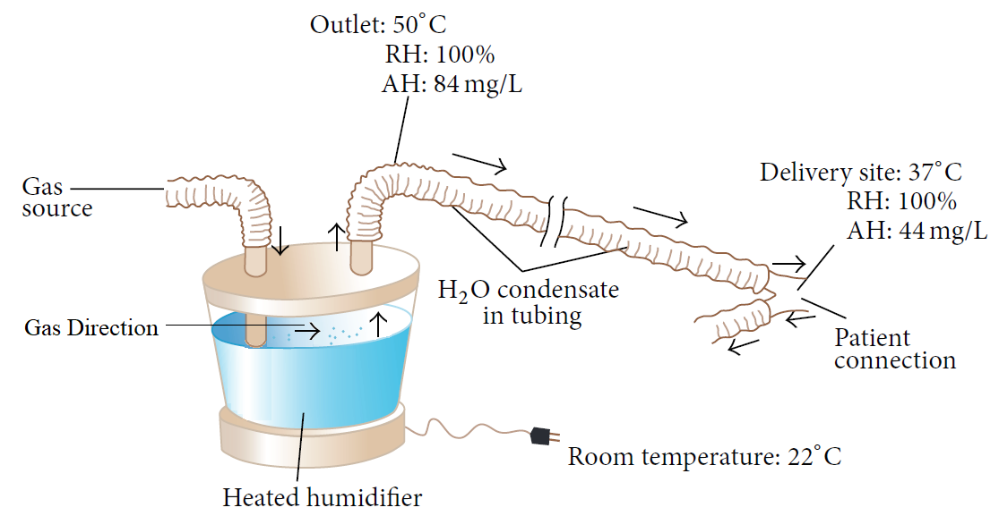

Figure 1: Heated humidifier and condensation, adapted from Egan’s Fundamentals of

Respiratory Care, 10th edition, St. Louis:Mosby-Elsevier;2012: 1424 **15**.

Due to the aforementioned shortcoming, heated humidifiers are usually supplied with heated wires (HWH) along the inspiratory limb to minimize this problem. These humidifiers have sensors at the outlet of the humidifier and at the Y-piece, near the patient. These sensors work in a closed-loop fashion, providing continuous feedback to a central regulator to maintain the desired temperature at the distal level (Y-piece). When the actual temperature exceeds or decreases beyond certain extreme level, the alarm system is triggered. Even though the ideal system should permit auto corrections based on humidity levels, commercially available sensors provide feedback based on changes in temperature

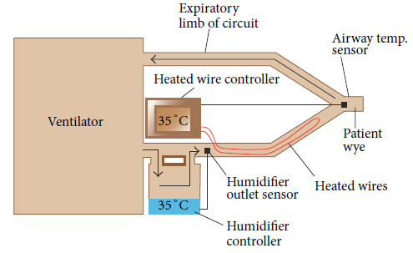

Figure 2: Humidifier with heated wire in the inspiratory limb, adapted from Egan’s Fundamentals of Respiratory Care, 10th edition, St. Louis: Mosby-Elsevier; 2012: 1424 **15**.

Figure 2 shows an active humidifier with a heated wire in the inspiratory limb; both temperature sensors, one at the side of the patient and the other at the outlet of the heated reservoir, are shown15. Usual temperature setting for the current heated humidifier is 37°C. The performance of humidifiers may be affected by room temperature, as well as patient minute ventilation. In the last situation, an increase in minute ventilation preserving the same temperature of the heated reservoir may not be adequate to deliver appropriate AH to the patient. Therefore, some humidifiers are supplemented with automatic compensation systems, which compute the amount of thermal energy needed to humidify certain volume of gas and change the temperature of the water reservoir accordingly.

Notably, some studies indicate that heated humidifiers without heated wires achieve higher levels of humidification than HWHs. Nevertheless, it is clear that they are associated with more condensation and respiratory secretions16. Hence, these types of humidifier are becoming increasingly unpopular among respiratory care providers. As previously mentioned, inspiratory heated wires can minimize condensation. However, exhaled air can form rainout in the expiratory limb. This has led to the utilization of double heated wire (DHW) circuits. This practice has replaced the use of single heated wires (SHW) circuits in some countries17. Another described technique to limit condensate in the expiratory limb is to use porous expiratory circuits18. Heated humidifiers have different designs and different techniques for humidification. Accordingly, these devices are classified as (1) bubble; (2) pass-over; (3) counter-flow; and (4) inline vaporizer. By literature survey it is evident that pass-over active humidifiers are most commonly used for ventilation purposes. Hence the scope of this report shall only be limited to the function of active pass-over humidifiers.

Passover. In passover humidifiers (Figure 3), gas passes over a heated water reservoir carrying water vapor to the patient. These are typically used for the purpose of invasive and non-invasive mechanical ventilation. Another variant of passover humidifiers is the wick one (Figure 3). In this type of device, the gas enters a reservoir and passes over a wick that acts as a sponge that has its distal end immersed in water. The wick pores provide more gas-water interface allowing for more humidification compared to simple passover humidifiers. The water reservoir is fed through a closed system. The system can be supplied with water either manually through a port or float feed system that ensures the water level remains constant all the time. As dry gas enters the chamber and travels through the wick, heat and moisture increase. Due to the fact that gas does not emerge underneath the water surface, no bubbles are generated. A third type of passover humidifier involves a hydrophobic membrane (Figure 3).

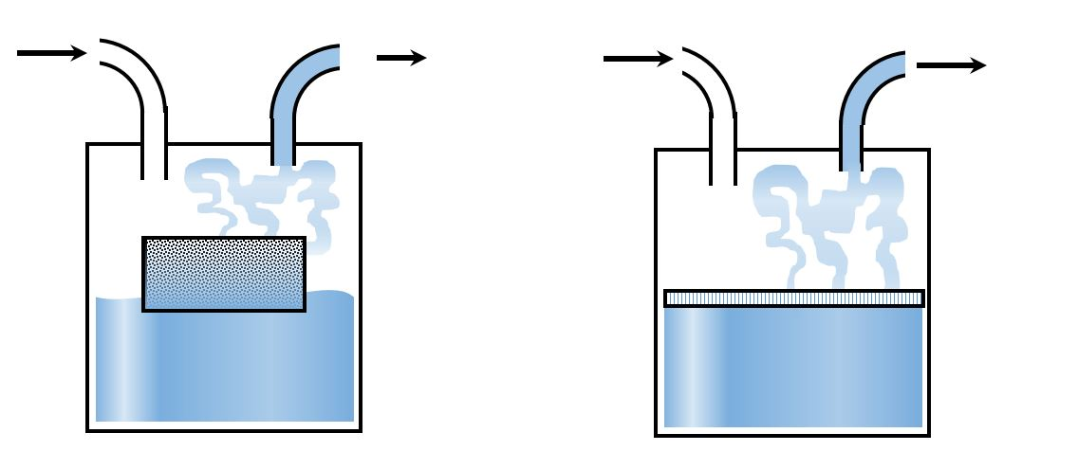

Figure 3: Working principle of pass over humidifier.

As with the wick device, dry gas passes through a membrane. Nevertheless, its hydrophobic characteristic only allows passage of water vapor, precluding liquid water to travel through it. Similarly, to the wick humidifier, bubbles and aerosols are not generated. As mentioned previously, these humidifiers are more commonly used during mechanical ventilation than bubble ones due to their lower flow resistance and absence of micro-aerosols. In all cases, a temperature probe is placed near the Y piece of the ventilator circuit to ensure delivery of gas with optimal temperature. As it was stated above, the presence of condensate in the tubing may increase resistance, which can decrease volume delivered in pressure controlled, or increase peak pressure in volume controlled modes. Despite the need of the aforementioned heated wires to avoid undesirable condensation, it is also worth mentioning that use of these wires does not come without thermal risks18. In terms of humidifier heating systems, currently there are 6 types of devices. The hot bed element (Figure 4E), which sits at the bottom of the humidifier, is one of the most commonly used. Other devices include the following:

* wraparound element: which surrounds the humidifier chamber (Figure 4B)
* collar element: which sits between the reservoir and the outlet (Figure 4C)
* immersion heater: which is placed directly inside the water reservoir (Figure 4D)
* heated wire: which is placed in the inspiratory limb of the ventilator (Figure 4E)

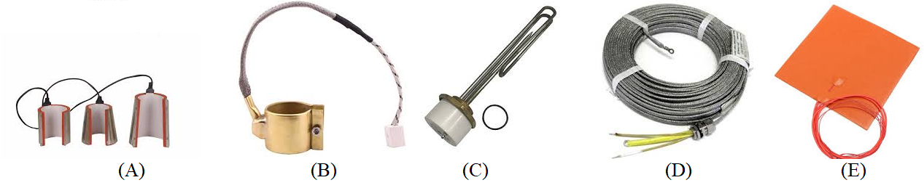

Figure 4: A). Wrap around, B). Collar element. C). Immersion, D). Wire and E). Heated bed.

# **MODELLING PASS-OVER HUMIDIFIER**

The humidification unit of the ventilator shall be limited to essential setting assuming the patient is kept well hydrated via other means. This is necessary since otherwise the dehydrated patient shall derive moisture from the lungs via moist air. This will cause the lung and the trachea to dry up and hence will make it prone to mucus plugging. The symptoms of this shall be thick mucus in the airway of the patient or an unexpected impulsive rise in the airway resistance. The following simplifying hypotheses have been introduced in order to mathematically model heat and mass exchange in the humidification chamber of the HH:

1. stationary operating conditions
2. perfect blending of gas-vapour phases
3. negligible pressure drop of gas phase
4. adiabatic behaviour of the whole system
5. liquid mean temperature equal to gas–liquid interface temperature.

The vapor mass rate exchanged between the liquid and the gas can be expressed as the following:

$W_{w}=G\left(U_{2}-U_{1}\right)$

Three energy and mass balance conditions must be considered in order to obtain outlet gas relative humidity and temperature as a function of the other parameters.

1. The heat transfer related to liquid vaporization enthalpy (latent heat)
2. The energy transfers due to temperature difference between gas & liquid (sensible heat).
3. The water mass transfer due to liquid vaporization.

The energy transfer (Qs) between the flowing gas and the heated liquid can be expressed as

$Q_{s}=h_{w}+q_{s}$

In the above equation, hw may be expressed as:

$h_{w}=W_{w}[λ+C_{p,w}\left(T_{s}-T_{o}\right)]$

Similarly, qs in the above equation can be expressed as the following:

$q_{s}=S(T_{s}-T_{2})$

We may combine equation (2), (3) and (4) as follows:

$Q_{s}=h_{w}+q_{s}=W_{w}\left[λ+C_{P,w}\left(T_{s}-T_{o}\right)\right]+S[h\left(T_{s}-T_{2}\right)]$

In the above, Qs can also be thought of as the difference in the heat of outlet gas and the inlet gas.

${G[C_{P,2}^{U}\left(T_{2}-T_{o}\right)-C_{P,1}^{U}\left(T_{1}-T_{o}\right)+λ(U_{2}-U_{1})=W}_{w}\left[λ+C_{P,w}\left(T_{s}-T_{o}\right)\right]+S[h\left(T_{s}-T_{2}\right)]$

Moreover, vapour mass transfer rate from liquid to gas phase can be expressed as:

$W_{W}=K_{Y}\left(U_{s}-U_{G}\right)S$

Considering perfect blending, U2=UG, we substitute (7) in (6) we get the following:

${G[C_{P,2}^{U}\left(T_{2}-T_{o}\right)-C_{P,1}^{U}\left(T_{1}-T_{o}\right)+λ(U_{2}-U_{1})=K}_{Y}\left(U_{s}-U_{G}\right)S*\left[λ+C_{P,w}\left(T_{s}-T_{o}\right)\right]+S[h\left(T_{s}-T_{2}\right)]$

Rearranging (8) to give U2 as a function of other parameters:



$U_{2}=\frac{\{-G\left[C_{P,2}^{U}\left(T_{2}-T_{o}\right)-C_{P,1}^{U}\left(T_{1}-T_{o}\right)\right]+GλU_{1}+K_{Y}U_{s}S\left[λ+C_{P,w}\left(T_{s}-T_{o}\right)\right]+S\left[h\left(T_{s}-T_{2}\right)\right]\}}{\{Gλ+K_{Y}S\left[λ+C_{P,w}\left(T_{s}-T_{o}\right)\right]\}}$

Figure 5: Schematization of the HH physical model. T1 and U1 inlet gas absolute temperature and humidity; T2 and U2 outlet gas absolute temperature and humidity; TS liquid absolute temperature at gas–liquid interface; S gas–liquid interface surface; G gas mass flow

In this case, Gas flowrate needs to be imported from ventilator CPU, surface temperature is approximated to be equal to the temperature of the hot plate, out flow temperature can be found using a k-type thermocouple, inlet temperature can be sensed with a similar sensor in the gas metering assembly. In the above equation setting an anatomical site shall fix the outlet temperature and humidity. Inlet humidity shall be known, inlet gas flowrate shall be known, inlet gas temperature can be closely monitored and the surface temperature shall be manipulated to change the outlet variables.

# **CONSTITUTIVE RELATIONSHIPS**

As reported in the literature, mass transfer coefficient (kY), reported in equation (7) has been evaluated as a function of the gas mass flowrate (G). Experimental trials performed for low humidification level and flowrates between 1-10L/min, allowed fitting of values of kY as a function of G with a first order curve. The equation on obtained by linear regression with R2=0.99 is as follows:

$K_{Y}=42.9G+401$

The values of ${\text{C}}_{\text{P,1}}^{\text{U}}$ and ${\text{C}}_{\text{P,2}}^{\text{U}}$ can be obtained from the following constitutive relations. For the following derivation, we assumed ideal gas behaviour.

$C_{P,Total}^{U}=\frac{C_{P,Dry Air}+C_{P,Vapour}+C_{P,Oxygen}}{G}$

From Jannot et. al 2018 (DOI: <https://doi.org/10.1002/9781119475057.app2>), the following relations can be used.

$C_{P,Dry Air}=[1002.5+275*{10}^{-6}(T_{K}-200)^{2}]*\left(G-AH*g-{FIO}_{2}*g*1.429\right)$

1. $C_{P,Vapour}=18877.2+0.49545\left(T_{C}\right)+8.1818*{10}^{-3}(T_{C})^{2}*\left(AH\right)*$ g
2. $C_{P_{O_{2}}}=0.916*(FIO_{2})$*g*1.429

Convective heat transfer coefficient:

$h=\frac{k*Nu}{d}$

$d=\sqrt{\frac{4S}{π}}$

$Nu=0.664*{Re}^{\frac{1}{2}}*{Pr}^{\frac{1}{3}}$

$Re=\frac{ρ*v*d}{μ};v=\frac{g(volumetric flow)}{S(mean surface\frac{g}{L})}$

$Re=ρ\frac{2g}{πra}*\frac{d}{μ}$

$Pr=\frac{μCp}{k}$

Empirically Equation 20 (DOI: <https://doi.org/10.1002/9781119475057.app2>) is given by:

$Pr=0.68+4.7*10^{-7}(T_{K}-500)$

The value of thermal conductivity and viscosity is given by:

$k=0.02624(\frac{T_{K}}{300})^{0.8646}$

$μ=\frac{1.458*10^{-6}T_{K}^{1.5}}{T_{K}+110.4}$

The value of US is given by the following relationship:

$P_{sat}=10^{A-\frac{B}{C+T_{C}}}$

Where, A= 8.07131, B=1730.3, C=233.426 and TC is temperature in Celsius and Pt is obtained from the steam table.

$U_{s}=P_{t}/P_{sat}$

# **FLOWCHART OF OPERATION**

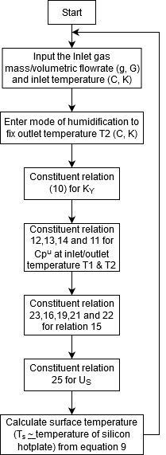

# **REFERENCES**

1. Shelly MP. The humidification and filtration functions of the airways. Respir Care Clinics N Am. 2006;12:139–48. [[PubMed](https://www.ncbi.nlm.nih.gov/pubmed/16828687)] [[Google Scholar](https://scholar.google.com/scholar_lookup?journal=Respir+Care+Clinics+N+Am.&title=The+humidification+and+filtration+functions+of+the+airways.&author=MP+Shelly&volume=12&publication_year=2006&pages=139-48&)]

2. Chikata Y, Oto J, Onodera M, Nishimura M. Humidification performance of humidifying devices for tracheostomized patients with spontaneous breathing. Respir Care. 2013;58:1442–8. [[PubMed](https://www.ncbi.nlm.nih.gov/pubmed/23386732)] [[Google Scholar](https://scholar.google.com/scholar_lookup?journal=Respir+Care.&title=Humidification+performance+of+humidifying+devices+for+tracheostomized+patients+with+spontaneous+breathing.&author=Y+Chikata&author=J+Oto&author=M+Onodera&author=M+Nishimura&volume=58&publication_year=2013&pages=1442-8&pmid=23386732&)]

3. Retamal J, Castillo J, Bugedo G, Bruhn A. Airway humidification practices in Chilean intensive care units. Rev Med Chile. 2012;140:1425–30. [[PubMed](https://www.ncbi.nlm.nih.gov/pubmed/23677188)] [[Google Scholar](https://scholar.google.com/scholar_lookup?journal=Rev+Med+Chile.&title=Airway+humidification+practices+in+Chilean+intensive+care+units.&author=J+Retamal&author=J+Castillo&author=G+Bugedo&author=A+Bruhn&volume=140&publication_year=2012&pages=1425-30&pmid=23677188&)]

4. Gross JL, Park GR. Humidification of inspired gases during mechanical ventilation. Minerva Anestesiol. 2012;78:496–502. [[PubMed](https://www.ncbi.nlm.nih.gov/pubmed/22269929)] [[Google Scholar](https://scholar.google.com/scholar_lookup?journal=Minerva+Anestesiol.&title=Humidification+of+inspired+gases+during+mechanical+ventilation.&author=JL+Gross&author=GR+Park&volume=78&publication_year=2012&pages=496-502&pmid=22269929&)]

5. Oto J, Nakataki E, Okuda N, Onodera M, Imanaka H, Nishimura M. Hygrometric properties of inspired gas and oral dryness in patients with acute respiratory failure during noninvasive ventilation. Respir Care. 2014;59:39–45. [[PubMed](https://www.ncbi.nlm.nih.gov/pubmed/23764857)] [[Google Scholar](https://scholar.google.com/scholar_lookup?journal=Respir+Care.&title=Hygrometric+properties+of+inspired+gas+and+oral+dryness+in+patients+with+acute+respiratory+failure+during+noninvasive+ventilation.&author=J+Oto&author=E+Nakataki&author=N+Okuda&author=M+Onodera&author=H+Imanaka&volume=59&publication_year=2014&pages=39-45&pmid=23764857&)]

6. Wood KE, Flaten AL, Backes WJ. Inspissated secretions a life-threatening complication of prolonged noninvasive ventilation. Respir Care. 2000;45:491–3. [[PubMed](https://www.ncbi.nlm.nih.gov/pubmed/10813225)] [[Google Scholar](https://scholar.google.com/scholar_lookup?journal=Respir+Care.&title=Inspissated+secretions+a+life-threatening+complication+of+prolonged+noninvasive+ventilation.&author=KE+Wood&author=AL+Flaten&author=WJ+Backes&volume=45&publication_year=2000&pages=491-3&pmid=10813225&)]

7. Restrepo RD, Walsh BK. American Association for Respiratory Care.Humidification during invasive and noninvasive mechanical ventilation 2012. Respir Care. 2012;57:782–8. [[PubMed](https://www.ncbi.nlm.nih.gov/pubmed/22546299)] [[Google Scholar](https://scholar.google.com/scholar_lookup?journal=+Respir+Care.&title=American+Association+for+Respiratory+Care.Humidification+during+invasive+and+noninvasive+mechanical+ventilation+2012.&author=RD+Restrepo&author=BK+Walsh&volume=57&publication_year=2012&pages=782-8&pmid=22546299&)]

8. Haitham S, Ashry A, Modrykamien A. Humidification during mechanical ventilation in the adult patient. Biomed Res Int. 2014;2014:715434. [[PMC free article](https://www.ncbi.nlm.nih.gov/pmc/articles/PMC4096064/)] [[PubMed](https://www.ncbi.nlm.nih.gov/pubmed/25089275)] [[Google Scholar](https://scholar.google.com/scholar_lookup?journal=Biomed+Res+Int.&title=Humidification+during+mechanical+ventilation+in+the+adult+patient.&author=S+Haitham&author=A+Ashry&author=A+Modrykamien&volume=2014&publication_year=2014&pages=715434&pmid=25089275&)]

9. Cruz C. Humidification systems in mechanical ventilation.Respiratory theraphyst opinion. Revista Teor a y praxis investigativa. 2008;3 [[Google Scholar](https://scholar.google.com/scholar_lookup?journal=+Revista+Teor+a+y+praxis+investigativa.&title=Humidification+systems+in+mechanical+ventilation.Respiratory+theraphyst+opinion.&author=C+Cruz&volume=3&publication_year=2008&)]

10. Shelly MP, Lloyd GM, Park GR. A review of the mechanisms and methods of humidification of inspired gases. Intensive Care Med. 1988;14:1–9. [[PubMed](https://www.ncbi.nlm.nih.gov/pubmed/3278023)] [[Google Scholar](https://scholar.google.com/scholar_lookup?journal=Intensive+Care+Med.&title=A+review+of+the+mechanisms+and+methods+of+humidification+of+inspired+gases.&author=MP+Shelly&author=GM+Lloyd&author=GR+Park&volume=14&publication_year=1988&pages=1-9&pmid=3278023&)]

11. Gheber L, Priel Z. Extraction of cilium beat parameters by the combined application of photoelectric measurements and computer simulation. Biophysical J. 1997;72:449–62. [[PMC free article](https://www.ncbi.nlm.nih.gov/pmc/articles/PMC1184336/)] [[PubMed](https://www.ncbi.nlm.nih.gov/pubmed/8994632)] [[Google Scholar](https://scholar.google.com/scholar_lookup?journal=Biophysical+J.&title=Extraction+of+cilium+beat+parameters+by+the+combined+application+of+photoelectric+measurements+and+computer+simulation.&author=L+Gheber&author=Z+Priel&volume=72&publication_year=1997&pages=449-62&)]

12. Kilgour E, Rankin N, Ryan S, Pack R. Mucociliary function deteriorates in the clinical range of inspired air temperature and humidity. Intensive Care Med. 2004;30:1491–4. [[PubMed](https://www.ncbi.nlm.nih.gov/pubmed/15024566)] [[Google Scholar](https://scholar.google.com/scholar_lookup?journal=Intensive+Care+Med.&title=Mucociliary+function+deteriorates+in+the+clinical+range+of+inspired+air+temperature+and+humidity.&author=E+Kilgour&author=N+Rankin&author=S+Ryan&author=R+Pack&volume=30&publication_year=2004&pages=1491-4&pmid=15024566&)]

13. Williams R, Rankin N, Smith T, Seakins P, Galler D. Relationship between the humidity and temperature of inspired gas and the function of the airway mucosa. Crit Care Med. 1996;24:1920,–9. [[PubMed](https://www.ncbi.nlm.nih.gov/pubmed/8917046)] [[Google Scholar](https://scholar.google.com/scholar_lookup?journal=Crit+Care+Med.&title=Relationship+between+the+humidity+and+temperature+of+inspired+gas+and+the+function+of+the+airway+mucosa.&author=R+Williams&author=N+Rankin&author=T+Smith&author=P+Seakins&author=D+Galler&volume=24&publication_year=1996&pages=1920,-9&pmid=8917046&)]

14. Branson RD, Gentile MA. Is humidification always necessary during noninvasive ventilation in the hospitalκ. Respir Care. 2010;55:209–16. [[PubMed](https://www.ncbi.nlm.nih.gov/pubmed/20105346)] [[Google Scholar](https://scholar.google.com/scholar_lookup?journal=Respir+Care.&title=Is+humidification+always+necessary+during+noninvasive+ventilation+in+the+hospitalκ.&author=RD+Branson&author=MA+Gentile&volume=55&publication_year=2010&pages=209-16&pmid=20105346&)]

15. R. M. Kacmarek, J. K. Stoller, and A. H. Heuer, Egan’s Fundamentalsof Rrespiratory Care, Mosby-Elsevier, St.Louis, Miss,USA, 10th edition, 2012.

16. M. Solomita, L. B. Palmer, F. Daroowalla et al., “Humidificationand secretion volume in mechanically ventilated patients,”Respiratory Care, vol. 54, no. 10, pp. 1329–1335, 2009.

17. R. J. Boots,N.George, J. L. Faoagali, J.Druery, K. Dean, and R.F. Heller, “Double-heater-wire circuits and heat-and-moistureexchangers and the risk of ventilator-associated pneumonia,”Critical Care Medicine, vol. 34, no. 3, pp. 687–693, 2006.

18. F. Lellouche, A. Lyazidi, P. Rodriguez, and L. Brochard, “Condensationin inspiratory and expiratory circuits of heated wirehumidifiers, evaluation of a new expiratory, “porous”, circuitand of new humidification compensation systems,” in Proceedingsof the 100th International Conference